# Selenium IDE Testing – Personal Account Creation

To test that our user stories for our textbook sharing project are able to meet their acceptance criteria, we are going using the selenium program to test whether each user story is able to accomplish what they were designed for. In this particular test we are experimenting to see if we are able to create a personal account for a user.

To create an account with our website you must do the following steps:

1. Go to <http://bookbook.azurewebsites.net/bookbook/pages/homepage.php>
2. Click on the ‘Create Account’ button
3. Enter in personal details for every field
   1. All fields must be filled in for account to be successfully created
   2. However selecting a Profile Image is optional
   3. Website only accepts QUT emails only
4. Once all details are input click on the ‘Submit Query’ button
5. If all details meet the requirements a green pop-up text will read “Account successfully created”. If details are not input correctly a red pop-up text will read one of the 3 messages:
   1. “Your passwords do not match.” – Passwords don’t match (See Figure 3)
   2. “All fields are required.” – Account is missing details (See Figure 2)
   3. “Please enter a valid QUT email address.” – Email is not a valid QUT email (See Figure 4)
6. Once account is successfully created, you are now able to logon
7. Click on the ‘Login’ button on the toolbar
8. Enter in account details and click the ‘Login’ button below
9. You are now part of our Textbook sharing website!

As seen in Figure 1 below, we used the Selenium program to test if our Personal Account Creation user story is able to meet the acceptance criteria. The test case in Figure 1 goes through each step mentioned above and it shows it is able to successfully complete each task without any failures.

The acceptance criteria for ‘Personal Account Creation’ are:

* A user signs up with their student email and a personal account is created for them.

Figure 4 shows that only QUT student emails are valid on our textbook sharing website, and Figure 1 and 5 shows the acceptance criteria is being met by successfully creating a personal account for any particular QUT student.

# APPENDIX

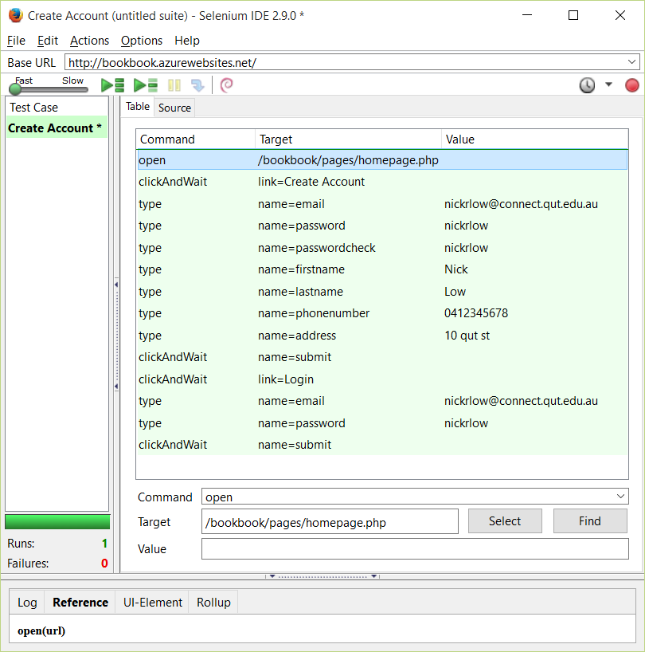

Figure

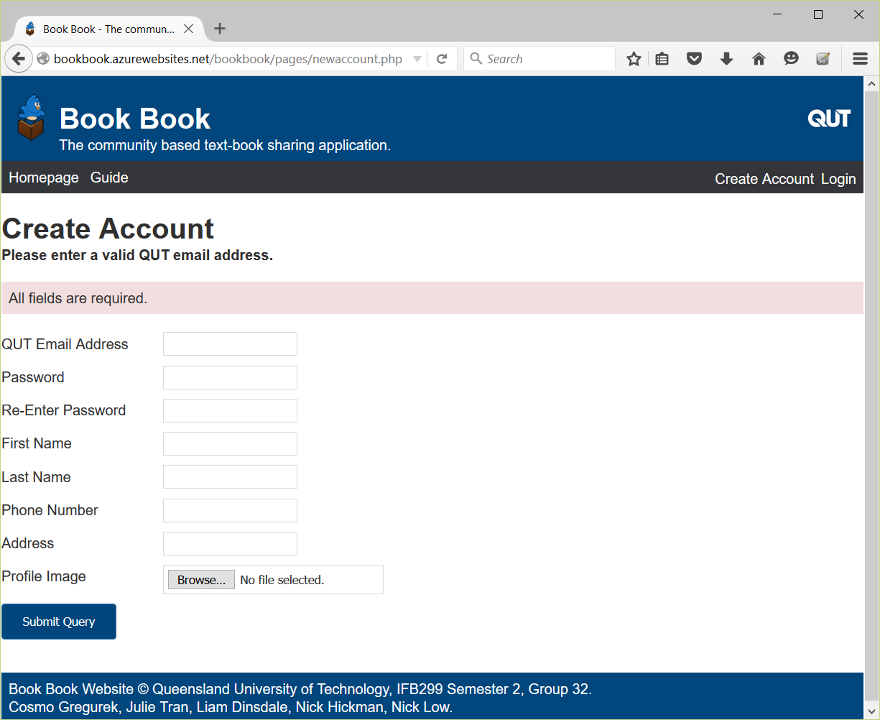

Figure

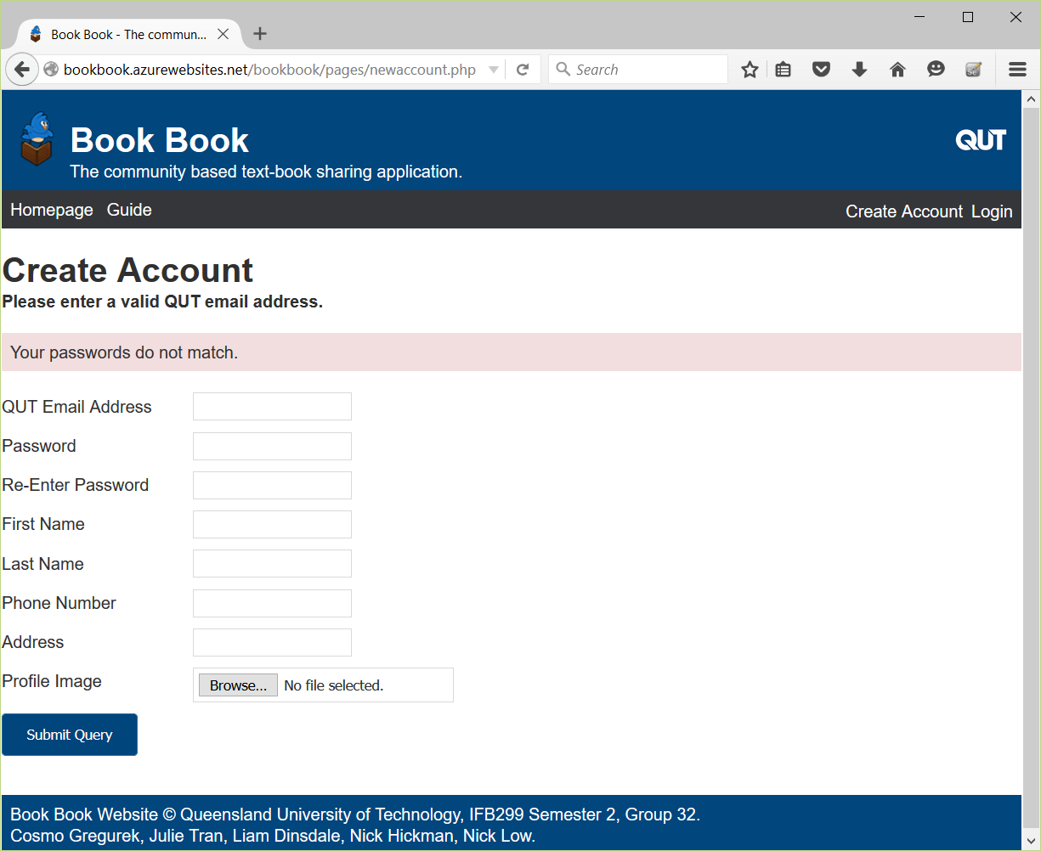

Figure

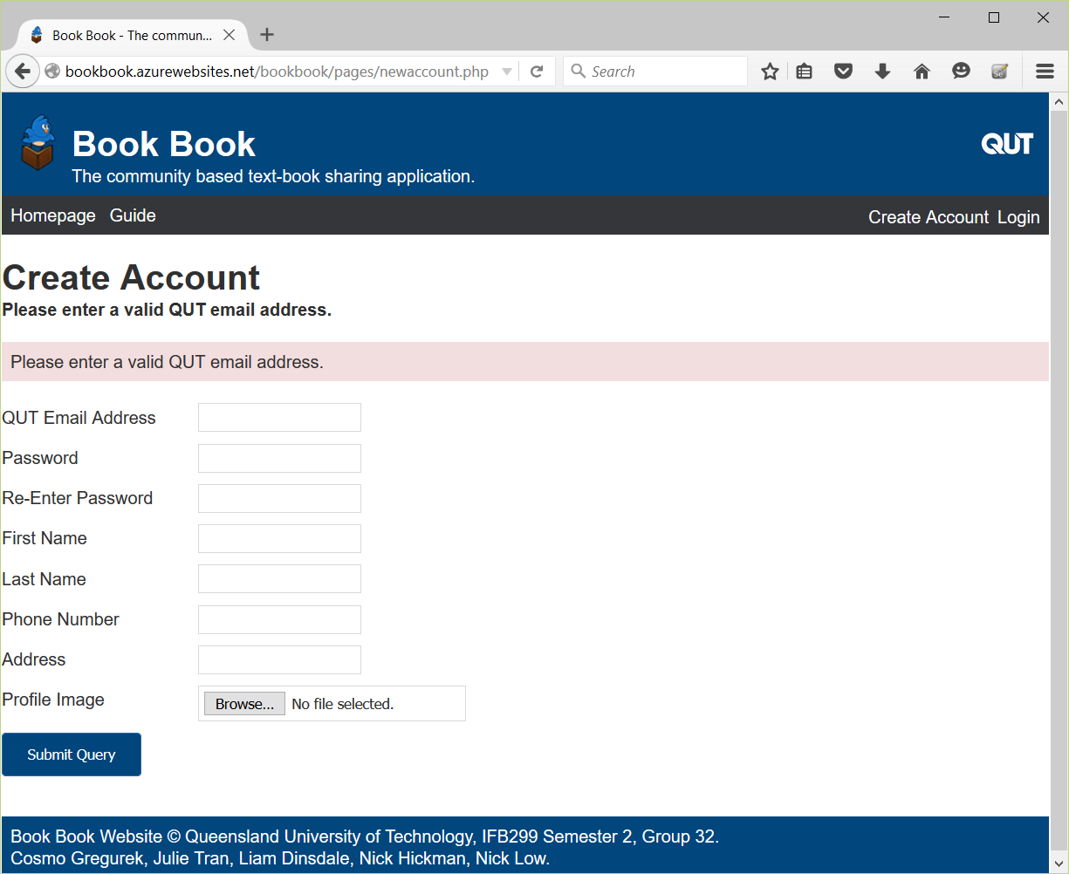

Figure

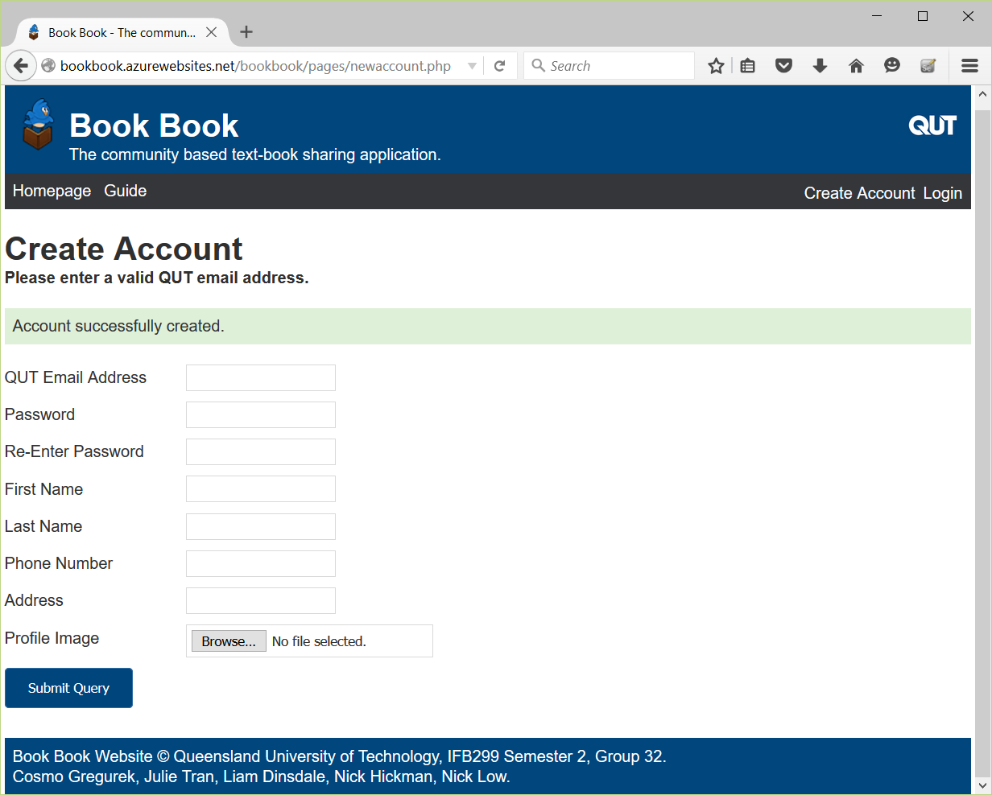

Figure